**CI and CD:**

CI/CD stands for Continuous Integration and Continuous Delivery (or Continuous Deployment), which are practices in software development aimed at automating and streamlining the process of building, testing, and delivering software. These practices contribute to a more efficient and reliable software development lifecycle.

Continuous Integration (**CI**) and Continuous Delivery (**CD**) are pivotal practices in modern software development, enabling teams to deliver high-quality software faster and more efficiently. Let’s break down what CI and CD entail, their importance, and how they work with a detailed example.

* **Continuous Integration (CI):** 
  + **Definition:** Continuous Integration is a development practice where developers frequently integrate their code changes into a shared repository, typically several times a day. Each integration is verified by an automated build and automated tests to detect integration errors as quickly as possible.
  + **Key Components:** 
    - **Version Control System (VCS):** A system like Git where developers push their code changes.
    - **Automated Build:** Tools like Jenkins, Travis CI, or CircleCI compile the code and package it.
    - **Automated Test:** Unit tests, integration tests, and other tests are run to ensure code changes do not break the application.
  + **Example:** Imagine a development team working on a web application. Each developer works on different features or bug fixes. They push their code changes to a shared Git repository multiple times a day. When a developer pushes code:
    - **Code-Check-in:** Developer commits code changes to the shared repository.
    - **Automated Build Trigger:** The CI server detects the change and triggers an automated build.
    - **Automated Tests Execution:** The CI server runs a suite of automated tests.
    - **Feedback:** If the build or tests fail, the developer gets immediate feedback and can fix the issue before it becomes a problem for others.
  + **Importance:** 
    - **Early Detection of Error:** Bugs and integration issues are detected early.
    - **Reduced Integration Problems:** Frequent integrations prevent "integration hell" where merging changes is complex and error-prone.
    - **Improved Code Quality:** Automated tests ensure high code quality and consistency.
* **Continuous Delivery (CD):** 
  + **Definition:** Continuous Delivery is an extension of CI, where code changes are automatically prepared for a release to production. It ensures that the software can be released reliably at any time. However, the final release step is a manual decision.
  + **Key Components:** 
    - **Automated Deployment Pipeline:** Deployment scripts and tools that automate the deployment process.
    - **Staging Environment:** An environment that mimics production where the latest version of the application is deployed for final testing.
    - **Manual Approval:** Human oversight to review and approve the deployment to production.
  + **Example:**

Continuing from the CI example, once the CI pipeline completes:

* **Deployment to Staging:** The application is automatically deployed to a staging environment.
* **Automated Tests in Staging:** End-to-end tests, performance tests, and security tests are run in the staging environment.
* **Manual Review and Approval:** The team reviews the staging environment. If everything looks good, they approve the release.
* **Production Deployment:** Upon approval, the application is deployed to production.
  + **Importance:** 
    - **Faster Release:** Reduces the time and effort required to release new features and fixes.
    - **Higher Quality:** Ensures that every change is tested and ready for production, reducing the risk of deploying faulty code.
    - **Flexibility:** The application can be released at any time, providing the ability to respond quickly to market changes or urgent issues.
* **CI/CD Example:**

**Scenario:** A team is developing an e-commerce application. They adopt CI/CD practices to streamline their development and deployment processes.

1. **Feature Development:** 
   * Developers work on different features or bug fixes in separate branches.
   * They frequently commit and push their changes to the shared Git repository.
2. **CI Process:** 
   * The CI server (e.g., Jenkins) detects the changes and triggers an automated build.
   * The application is compiled, and automated unit tests are run.
   * If the build or tests fail, developers are notified immediately to fix the issues.
3. **CD Process:** 
   * Successful builds are deployed to a staging environment.
   * Automated integration tests, end-to-end tests, and performance tests are executed in the staging environment.
   * The team reviews the application in the staging environment.
   * Upon approval, the changes are deployed to the production environment using automated deployment scripts.
4. **Monitoring and Feedback:** 
   * The production environment is continuously monitored for any issues.
   * Feedback from monitoring tools and user reports is used to improve future releases.

* **Benefits:** 
  + **Increased Deployment Frequency:** Features and fixes are delivered to users faster.
  + **Reduced Deployment Risk:** Automated tests and staging deployments catch issues before they reach production.
  + **Improved Collaboration:** Developers work more efficiently with faster feedback and fewer integration issues.

CI and CD are essential practices for modern software development, enabling teams to deliver high-quality software quickly and reliably. By automating the integration, testing, and deployment processes, teams can reduce errors, improve collaboration, and respond swiftly to changes and feedback. Implementing CI/CD requires a robust infrastructure and a commitment to automation, but the benefits in terms of efficiency, quality, and speed are well worth the effort.

**Tools for CI/CD:**

* **Jenkins:** An open-source automation server that supports building, testing, and deploying code. Jenkins is highly extensible through plugins, making it adaptable to various use cases. An open-source CI/CD solution designed for cloud-native applications and Kubernetes. It automates the process of building, deploying, and promoting applications on Kubernetes.
* **GitHub Actions:** GitHub Actions is a **CI/CD** and automation platform provided by GitHub. It allows you to define workflows directly in your GitHub repository to automate various aspects of your software development process. GitHub Actions enables you to build, test, and deploy your applications with ease.
* **CircleCI:** A cloud-based **CI/CD** service that automates the software development process. It supports multiple programming languages and integrates with popular version control systems.
* **GitLab:** Integrated within GitLab, it provides a built-in **CI/CD** solution. It allows defining CI/CD pipelines directly in the GitLab repository. In addition to CI, GitLab also offers CD capabilities. It allows you to define and manage deployment environments and release strategies.

**GitHub Action:**

GitHub Actions is a powerful automation and **CI/CD** tool provided by GitHub. It allows you to automate workflows for building, testing, and deploying your code right from your GitHub repository. You can create custom workflows that can be triggered by various GitHub events like push, pull request, or on a schedule.

* **Key Features of GitHub Actions:** 
  + **Integration with GitHub:** Seamlessly integrates with GitHub repositories.
  + **Custom Workflows:** Define custom workflows using YAML syntax.
  + **Event Triggers:** Trigger workflows on different events such as push, pull request, issue creation, etc.
  + **Parallel Execution:** Run multiple jobs in parallel, optimizing the CI/CD pipeline.
  + **Reusable Actions:** Use community-contributed actions or create your own reusable actions.
  + **Cross-Platform Support:** Run workflows on Linux, macOS, and Windows runners.
* **Components of GitHub Actions:** 
  + **Workflows:** Defined in YAML files located in the **‘.github/workflows’** directory of the repository. Workflows are triggered by specified events.
  + **Events:** Specific activities that trigger workflows, such as push, pull request, or schedule.
  + **Jobs:** A workflow can contain multiple jobs, and each job runs on a different runner.
  + **Steps:** Individual tasks within a job. Each step can run commands or actions.
  + **Actions:** Reusable units of code that can be included as steps in workflows. Actions are like functions that perform specific tasks.
  + **Runners:** Servers that run your workflows. GitHub provides hosted runners, but you can also use self-hosted runners.
* **Example of a GitHub Actions Workflow:**

Consider an example where we want to set up a CI pipeline that builds a Node.js application and runs tests whenever code is pushed to the repository.

* + **Creating a Workflow file:** 
    - Create a directory named **‘.github/workflows’** in your repository.
    - Create a file named **‘CI.yaml’** inside the directory.
  + **Defining the Workflow:**

Here's an example of **‘CI.yaml’** file:

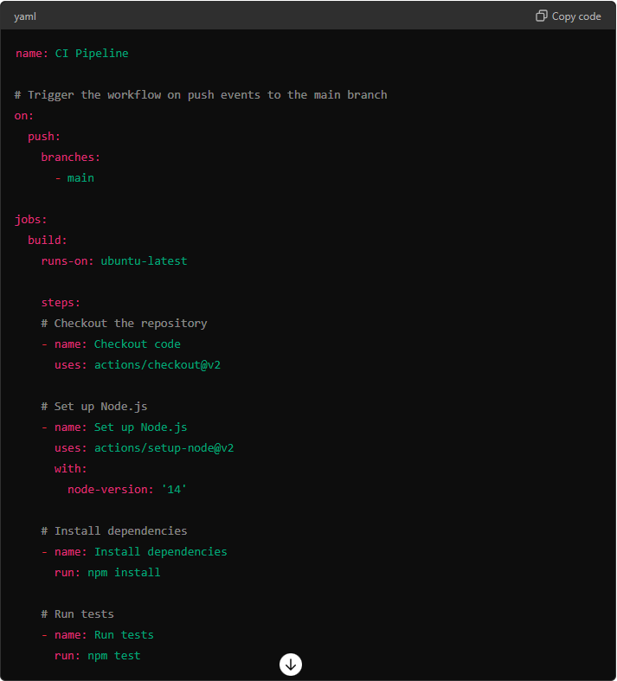

* **Explanation of Components:** 
  1. **Workflow:** 
     + **name:** Names the workflow.
     + **on:** Defines the event that triggers the workflow. In this case, the workflow is triggered on **‘push’** events on the **‘main’** branch.

* 1. **Jobs:** 
     + **jobs:** Contains one or more jobs that run in parallel.
     + **build:** A job named **‘build’** is defined.
     + **runs-on:** Specifies the type of runner to run the job. **‘ubuntu-latest’** means it will use the latest version of Ubuntu.
  2. **Steps:** 
     + **steps:** A sequence of tasks to be executed in the job.
     + **Checkout code:**
       - **name:** Describes the step.
       - **uses:** Refers to an action, **‘actions/checkout@v2’**, to check out the code from the repository.
     + **Set up Node.js:**
       - **name:** Describes the step.
       - **uses:** Refers to an action, **‘actions/checkout@v2’**, to set up a Node.js environment.
       - **with:** Specifies additional parameters for the action, such as the **‘npm-version’**.
     + **Install Dependencies:** 
       - **name:** Describes the step.
       - **run:** Directly runs a shell command to install dependencies using **‘npm install’**.
     + **Run tests:** 
       - **name:** Describes the step.
       - **run:** Directly runs a shell command to execute tests using **‘npm test’**.
* **Real-World Example:**

Imagine you are developing a web application and want to ensure that every code change is automatically tested and deployed. Using GitHub Actions, you can set up a CI/CD workflow that:

1. **Triggers** whenever a pull request is opened or a commit is pushed to the main branch.
2. **Checks out** the code from the repository.
3. **Sets up** the necessary programming environment (e.g., installs Node.js)
4. **Install Dependencies** specified in a file (like **‘package.json’**).
5. **Runs automated tests** to ensure the new code does not introduce any bugs.
6. **Deploys** the application to a staging environment if tests pass.

Here is **‘ci.yaml’** file:

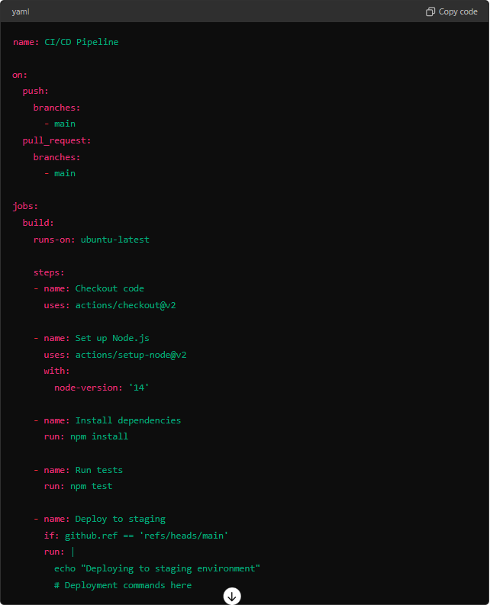

**In this workflows:**

* It runs on both **‘push’** and **‘pull_request’** events.
* It uses **‘actions/setup-node@v2’** to setup Node.js.
* It runs **‘npm install’** to install dependencies and **‘npm test** to run tests.
* It includes a conditional deployment step that only runs on the **‘main’** branch.

**Events in GitHub Actions:**

**Events** are specific activities that trigger workflows in GitHub Actions. They are defined within the **‘on’** key in the workflow YAML file. Events can include activities such as pushing code, creating pull requests, scheduling a time-based trigger, and many others.

* **Common Types of Events:** 
  + **push:** Triggered when code is pushed to a repository.
  + **pull_request:** Triggered when a pull request is opened, synchronized, or closed.
  + **schedule:** Triggered at scheduled times using cron syntax.
  + **workflow_dispatch:** Triggered manually through the GitHub Actions UI.
  + **repository_dispatch:** Triggered by an external event to a repository.
* **Example of Events:**

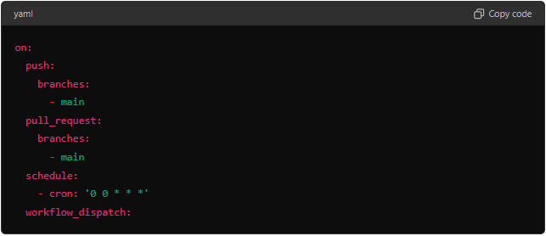

**In this example:**

* The workflow is triggered on any push to the **‘main’** branch.
* It also triggers on pull requests targeting the **‘main’** branch.
* Additionally, it runs every day at midnight UTC.
* It can be manually triggered via the GitHub Actions UI.
* **Importance:** 
  + Allow for automation based on specific activities within the repository, ensuring that workflows run at appropriate times.

**Actions in GitHub Actions:**

**Actions** are reusable units of code that can be used in workflows. They perform specific tasks like checking out code, setting up a programming language, running tests, deploying applications, etc. Actions can be custom-built or sourced from the GitHub Marketplace.

* **Types of Actions:** 
  + **Docker Container Actions:** Actions that run in a Docker container.
  + **JavaScript Actions:** Actions written in JavaScript and executed directly in the runner environment.
  + **Composite Actions:** Actions that combine multiple steps and other actions into a single action.
* **Example of Actions:**

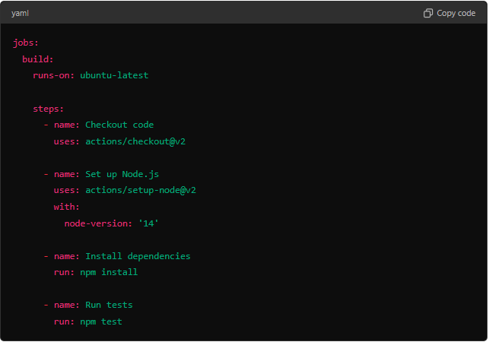

**In this example:**

* **actions/checkout@v2:** A pre-built action that checks out the repository's code.
* **action/setup-node@v2:** A pre-built action that sets up a Node.js environment.
* **run: npm install** and **run: npm test:** Shell commands run directly on the runner to install dependencies and run tests.

**Combining Events and Actions: An Example Workflow**

Here's a more detailed example workflow that combines events and actions to create a CI/CD pipeline for a Node.js application:

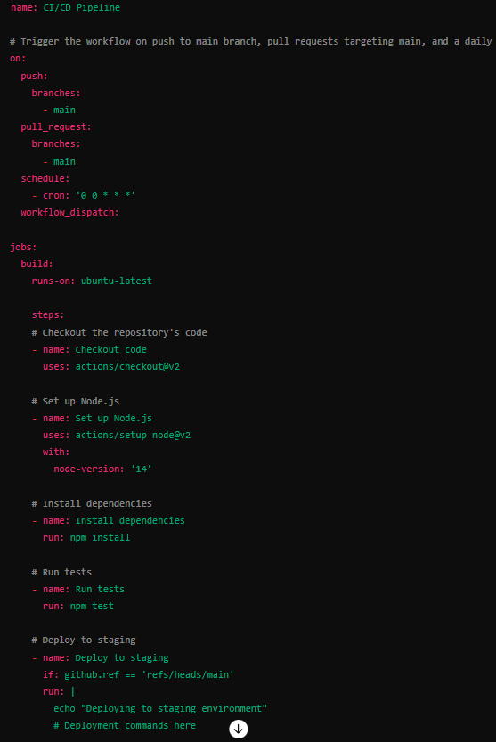

**Explanation:**

* **Events:** 
  + **push:** The workflow runs on every push to the **‘main’** branch.
  + **pull_request:** The workflow runs for pull requests targeting the **‘main’** branch.
  + **schedule:** The workflow runs daily at midnight.
  + **workflow_dispatch:** The workflow can be manually triggered.
* **Actions:** 
  + **Checkout code:** Uses the **‘actions/checkout@v2’** action to check out the repository's code.
  + **Set up Node.js:** Uses the **‘actions/checkout@v2’** action to set up a Node.js environment.
  + **Install dependencies:** Runs the shell command **‘npm install’** to install dependencies.
  + **Run tests:** Runs the shell command **‘npm test’** to run tests.
  + **Deploy to staging:** Conditionally runs a deployment script if the workflow is triggered by a push to the **‘main’** branch.

By leveraging events and actions in GitHub Actions, you can create powerful, automated workflows that enhance your development, testing, and deployment processes, leading to more reliable and efficient software delivery.

**Git Branching Strategy:**

A branching strategy in GitHub (or any version control system) is a set of conventions used to manage the various branches within a repository. This strategy helps in organizing and maintaining code versions in a systematic and predictable manner, ensuring smooth collaboration among developers and efficient code integration and deployment processes.

* **Building the best Branching Strategy for Industry-Grade Applications:**
  + **Git Flow:**

**Git Flow** is a branching model developed by Vincent Driessen. It is highly suitable for projects that have a scheduled release cycle and need to support multiple versions at a time.

* **Key Branches in Git Flow:** 
  + **master or main:** This is the main branch where the source code of HEAD always reflects a production-ready state.
  + **develop (dev):** This is the main branch for development where the source code of HEAD always reflects a state with the latest delivered development changes for the next release.
  + **feature branches:** Created from develop and used for developing new features.
  + **release branches:** Created from develop when enough features are completed for a release. Used for final bug testing before merging into master.
  + **hotfix branches:** Created from master to fix bugs in the production environment.
* **Best Practices for Industry-Grade Applications:** 
  + **Choose the Right Strategy:** Select a branching strategy (**Git Flow**) that fits your project's needs, team size, and release cadence.
  + **Consistent Naming Convention:** Use clear and consistent naming for branches (e.g., **‘feature/feature-name’**, **‘bugfix/bug-name’**).
  + **Regular Integration:** Frequently merge feature branches into the main branch to reduce merge conflicts and ensure continuous integration.
  + **Automated Testing:** Implement **CI/CD** pipelines to run automated tests on every push and pull request.
  + **Code Reviews:** Use pull requests and code reviews to ensure code quality and knowledge sharing.
  + **Documentation:** Document your branching strategy and workflows to ensure all team members understand and follow the process.
* **Example of an Industry-Grade Application:**

For a large e-commerce platform with multiple teams working on different features and services, you might use **Git Flow** for its robust support of multiple versions and release cycles.

* **master:** Always contains the production-ready code.
* **develop:** Used by the development team to integrate features for the next release.
* **features branches:** Created for new features like **‘feature/shopping-cart’, ‘feature/user-authentication’**.
* **release branches:** Created when preparing for a new release, e.g., **‘release/2.0’** or **‘release-2.0’**.
* **hotfix branches:** Created to quickly address critical bugs in production, e.g., **‘hotfix/payment-bug’**.
* **test branch:** Test the latest feature or features by applying complete CI/CD (if needed), e.g., **‘test/feature/user-authentication/api-test’**.

By following this strategy, the e-commerce platform can manage complex development workflows, support multiple simultaneous feature developments, and ensure high-quality, stable releases.

This structured approach allows for better coordination among teams, streamlined integration of new features, and rapid response to production issues, making it suitable for industry-grade applications.

**CI/CD Using Jenkins:**